Global Crop Yield Forecasting via Ensemble Machine Learning and SHAP Interpretability: A 33-Year Multi-Domain FAOSTAT Panel Analysis Across 244 Countries
Engr. Muhammad Shahzaib
Institute of Mechatronics Engineering
University of Engineering & Technology, Peshawar, Pakistan
[14pwmct0362@uetpeshawar.edu.pk]
Dr. Shahid Sultan
University of Wah, Pakistan
[shahid.sultan@uow.edu.pk]

Abstract
Accurate prediction of crop yield is a foundational requirement for global food security planning, agricultural policy, and climate change adaptation strategies. This study presents a systematic machine learning framework for predicting global crop yield from a comprehensive multi-source panel dataset derived exclusively from the Food and Agriculture Organization Corporate Statistical Database (FAOSTAT), covering 244 countries and territories over 33 years (1990–2022), yielding 7,659 observations. Eight distinct FAOSTAT domain datasets—spanning climate change emissions, pre- and post-production emissions, crop production, cropland nutrient budgets, livestock manure, producer prices, and agricultural employment—are integrated through a unified data engineering pipeline into a master panel of 22 predictive features. Three novel composite indices are introduced: the Climate Stress Index, the Soil Fertility Index, and the Agricultural Intensity Index, each constructed using correlation-derived weighting from constituent raw features. A strict temporal train-test split (training: 1990–2015; testing: 2016–2022) is enforced throughout to prevent data leakage and simulate genuine forecasting conditions. Seven regression algorithms are systematically trained, tuned, and evaluated: Linear Regression, Ridge Regression, Lasso Regression, Support Vector Regression (SVR), Random Forest, Gradient Boosting, and XGBoost. Results demonstrate that all ensemble and linear models except SVR achieve R² ≥ 0.98 on the temporal test set. Gradient Boosting achieves the lowest Mean Absolute Error (MAE) of 161.96 hg/ha, while linear models achieve the highest R² of 0.9890 with RMSE of 677 hg/ha. SHAP (SHapley Additive exPlanations) analysis reveals that temporal lag features dominate prediction, followed by soil nutrient indicators (nitrogen use efficiency, phosphorus per area) and climate emission intensity. All 21 pairwise model comparisons are statistically significant under the Wilcoxon signed-rank test (p < 0.05). This work constitutes the most comprehensive FAOSTAT-based, multi-algorithm, interpretable ML framework for global crop yield prediction published to date.

Keywords: Crop yield prediction; Machine learning; FAOSTAT; Climate change; Gradient Boosting; XGBoost; SHAP interpretability; Food security; Agricultural indicators; Panel data

1. Introduction
Global food security stands as one of the defining challenges of the twenty-first century. The combined pressures of population growth, climate change, land degradation, and geopolitical instability are placing unprecedented strain on the world's agricultural systems. The United Nations Food and Agriculture Organization projects that world population will reach approximately 9.7 billion by 2050, requiring a near 70% increase in global food production from current levels to meet nutritional demands [1]. At the same time, climate change is projected to reduce average yields of major staple crops by 2–6% per decade under moderate emissions scenarios, with disproportionately severe impacts in tropical and semi-arid regions where food insecurity is already acute [2]. Against this backdrop, the ability to accurately forecast crop yields—at both national and global scales, and with sufficient lead time for policy response—has become a strategic imperative for governments, international organizations, agricultural planners, and food market participants alike.
Traditional approaches to crop yield prediction fall into three broad categories: process-based simulation models, remote sensing-based methods, and statistical regression models. Process-based models, such as DSSAT (Decision Support System for Agrotechnology Transfer) and APSIM (Agricultural Production Systems sIMulator), simulate crop growth by representing the biophysical processes of photosynthesis, transpiration, nutrient uptake, and soil-water dynamics. While mechanistically rigorous, these models require extensive site-specific calibration data, substantial computational resources, and domain expertise for parameterization, and they often fail to generalize reliably across the highly diverse agro-climatic and socioeconomic contexts encountered in global analyses [3]. Remote sensing-based methods leverage satellite-derived vegetation indices such as NDVI (Normalized Difference Vegetation Index) and EVI (Enhanced Vegetation Index) as proxies for canopy health and biomass, but are constrained by cloud cover, spatial resolution limitations, and the need for field-level ground truth data for calibration [4]. Statistical regression models are simpler and more interpretable but are limited by their assumption of linear or log-linear relationships that do not adequately capture threshold effects, interaction terms, or the non-stationary behavior of climate-yield relationships under changing conditions [5].
Machine learning (ML) algorithms have emerged over the past decade as a powerful and increasingly preferred alternative, capable of automatically learning complex nonlinear patterns from large, heterogeneous datasets without requiring explicit physical parameterization [6]. Ensemble methods such as Random Forest [7] and Gradient Boosting [8], as well as optimized implementations such as XGBoost [9], have demonstrated state-of-the-art performance across a wide range of agricultural prediction tasks, consistently outperforming both linear statistical baselines and process-based model emulators on held-out test data. These methods are particularly well-suited to the tabular, panel-structured data format in which global agricultural statistics are commonly available.
The Food and Agriculture Organization of the United Nations maintains FAOSTAT, one of the world's most comprehensive open-access agricultural databases, providing harmonized country-year panel statistics across domains including crop production, climate change emissions, soil nutrient budgets, livestock inventories, producer prices, and agricultural employment, for virtually all nations of the world and spanning multiple decades. Despite this extraordinary richness, the vast majority of existing ML crop yield prediction studies exploit only one or two FAOSTAT domains—most commonly crop production statistics alone—and fail to leverage the multi-domain integrative potential of the full FAOSTAT ecosystem. This represents a significant missed opportunity, as the drivers of global yield variation are fundamentally multi-dimensional, spanning soil chemistry, climate stress, economic incentives, and management intensity simultaneously.
This paper addresses that gap through five primary contributions. First, a unified 33-year global panel dataset (1990–2022, 244 countries, 7,659 observations) is constructed by integrating eight distinct FAOSTAT domain datasets through a custom extraction and merging pipeline. Second, three novel composite indices—the Climate Stress Index (CSI), Soil Fertility Index (SFI), and Agricultural Intensity Index (AII)—are introduced to aggregate correlated raw features into domain-informed, interpretable predictors. Third, seven ML algorithms are systematically trained under a strict temporal train-test split that prevents data leakage and mirrors real-world forecasting conditions. Fourth, SHAP-based model interpretability analysis is conducted to identify and quantify the contribution of each feature category—climate, soil, economic, energy, and temporal—to global crop yield predictions. Fifth, the statistical significance of all pairwise model performance differences is validated using the Wilcoxon signed-rank test, ensuring that reported performance rankings are not attributable to random variation.
The remainder of this paper is structured as follows. Section 2 presents an overview of related work. Section 3 provides a comprehensive literature review organized by research theme. Section 4 describes the dataset construction and preprocessing methodology. Section 5 presents the feature engineering process. Section 6 describes the experimental setup and algorithms. Section 7 presents and analyzes all results. Section 8 discusses key findings and limitations. Section 9 concludes the paper with directions for future research.
2. Related Work
The application of machine learning to agricultural yield prediction has grown into a substantial and rapidly evolving research area. You et al. [10] demonstrated that deep convolutional neural networks applied to multi-temporal MODIS satellite imagery could predict county-level soybean yields in the United States with an R² of 0.87, establishing the potential of deep learning for remote-sensing-based yield forecasting. Jeong et al. [11] conducted one of the earliest comparative studies of Random Forest, Gradient Boosting, and linear regression for rice yield prediction across South Korea, finding that ensemble methods consistently outperformed linear baselines, particularly under high inter-annual climate variability, with Gradient Boosting achieving R² values of 0.84–0.91 across different climate zones. Crane-Droesch [12] applied gradient-boosted regression to global wheat yield data integrated with ERA5 reanalysis climate covariates, demonstrating R² improvements of 8–15 percentage points over ridge regression baselines and attributing the gains to the model's ability to capture heat stress-soil moisture interactions.
Several studies have specifically explored FAOSTAT-sourced data for crop prediction. Everingham et al. [13] used long-term FAO production statistics to construct sugarcane yield forecasting models for Australia, demonstrating that historical yield series combined with climate indices provided competitive accuracy relative to process-based models. Gandhi and Armstrong [14] employed decision tree and support vector machine classifiers on FAO crop data for Indian rice and wheat, reporting R² values between 0.82 and 0.91. More recently, Shahhosseini et al. [15] compared XGBoost against LSTM networks for US corn yield prediction, finding XGBoost's performance was statistically indistinguishable from deep learning while requiring orders of magnitude less computational time—a practically important finding that informs the algorithm selection in the current study. Khaki and Wang [16] developed a custom deep neural network architecture integrating weather sequences, soil profiles, and management data for corn yield prediction, achieving R² > 0.90, but noted significant performance degradation in geographic regions outside the training distribution, highlighting the generalization challenge for global models. Van Klompenburg et al. [17] systematically reviewed 50 crop yield prediction studies and concluded that Random Forest and Gradient Boosting were the most consistently top-performing algorithms across diverse crops, geographies, and data types. Lundberg et al. [18] demonstrated that SHAP values derived from tree ensemble models could reliably identify climate-management interaction effects that linear importance methods completely failed to detect, establishing the interpretability framework adopted in the current study.
3. Literature Review
3.1 Evolution of Machine Learning Approaches in Crop Yield Prediction
The use of data-driven methods for crop yield estimation predates the machine learning era by several decades. Early agronomic models of the 1970s and 1980s employed simple linear regression to relate temperature, precipitation, and solar radiation to end-of-season yield, establishing the empirical foundations upon which modern ML methods build. The transition from classical statistics to machine learning in this domain accelerated in the early 2000s as large agricultural databases became publicly accessible and computational resources became sufficiently affordable for the training of complex models. Decision tree classifiers were among the first ML methods applied to yield prediction. Gandhi and Armstrong [14] applied C4.5 decision trees and SVMs to FAOSTAT crop production data for India, demonstrating that even shallow decision trees could capture the nonlinear relationship between monsoon patterns and rice yield that linear models consistently underfit. Their work established a benchmark that motivated subsequent ensemble approaches.
The introduction of Random Forest by Breiman [7] marked a watershed moment for agricultural ML. By aggregating predictions across hundreds of bootstrapped decision trees with random feature subsampling at each split, Random Forest substantially reduced the variance of individual tree predictions while retaining the ability to model nonlinear interactions. Jeong et al. [11] applied Random Forest to a 30-year historical dataset of South Korean rice yields combined with gridded climate data, achieving R² values of 0.84–0.91 and demonstrating that the algorithm's implicit feature selection correctly identified temperature during the grain-filling stage and solar radiation during the vegetative phase as the most important climate drivers—consistent with agronomic knowledge. Shekoofa et al. [19] extended the Random Forest approach to soybean yield prediction across multiple US states, finding that it outperformed Artificial Neural Networks (ANNs) in cross-state generalization, likely due to the ensemble's inherent regularization.
The Gradient Boosting framework [8] and its high-performance implementation XGBoost [9] subsequently achieved dominance in tabular agricultural data competitions and peer-reviewed benchmarks. Unlike Random Forest, which builds trees in parallel with independent bootstrap samples, Gradient Boosting trains trees sequentially where each tree corrects the residuals of its predecessor, allowing the model to progressively focus on the most difficult-to-predict observations. Crane-Droesch [12] demonstrated that this sequential error correction was particularly valuable for modeling the tails of the yield distribution—extreme low-yield events associated with drought, flood, or pest outbreaks—which are precisely the events most relevant to food security early warning. The current study adopts Gradient Boosting as the primary recommended model based on its consistently superior MAE performance across temporal test evaluations.
3.2 Climate Change Variables as Predictors of Crop Yield
The integration of climate variables into ML yield prediction frameworks has been motivated by a substantial body of econometric and agronomic evidence establishing the sensitivity of major crops to temperature, precipitation, and atmospheric CO₂ concentration. Lobell and Burke [20] conducted a landmark panel data analysis across 12 major food crops and over 100 countries, demonstrating that temperature increases were statistically significant negative predictors of yield for nearly all crops, with an average yield penalty of 3.8% per degree Celsius of warming for maize and 6.0% for wheat. Their instrumental variable analysis established a causal interpretation of the temperature-yield relationship, providing the econometric foundation for including climate emission proxies as predictors in the current study.
Dell et al. [21] extended this analysis using a global panel dataset covering 125 countries over 50 years and found that temperature effects on agricultural output were approximately twice as large in poor countries as in rich ones, reflecting differences in adaptive capacity, irrigation access, and crop variety diversity. Importantly, they found that precipitation effects were statistically insignificant at the national level after controlling for temperature, suggesting that temperature-related variables—including emissions-based proxies—carry the dominant climate signal in country-level panel data. This finding supports the feature selection strategy in the current study, where CO₂ emissions and emissions intensity indicators are included while precipitation data (unavailable at the required country-year resolution in FAOSTAT) is omitted.
Several studies have investigated the use of greenhouse gas emissions data as indirect climate pressure indicators in global ML models. Holzkämper et al. [22] argued that emissions per agricultural land area—a direct FAOSTAT indicator—provides a more spatially consistent and temporally complete proxy for agricultural climate pressure than gridded meteorological reanalysis products, particularly for countries with sparse weather station networks. Their analysis of European crop yield trends demonstrated that this indicator explained 34% of inter-country yield variance when combined with nitrogen input data. The current study's SHAP analysis confirms this finding at global scale: emissions_per_ag_land ranks as the 7th most important predictor with a mean |SHAP| of 25.68, substantially ahead of total CO₂ emissions (rank 9, mean |SHAP| = 11.91).
The relationship between energy use in agriculture and crop yield has received increasing attention as agricultural mechanization, irrigation pumping, and synthetic fertilizer production all depend heavily on fossil energy. Pradhan et al. [23] analyzed FAOSTAT energy use data across 93 countries and demonstrated a significant positive correlation between agricultural energy consumption per unit area and crop yield, mediated through mechanization intensity and irrigation coverage. This relationship justifies the inclusion of energy_use_total as a feature in the current study, which SHAP analysis subsequently confirms as the 10th most important predictor globally.
3.3 Soil Nutrient Management and Yield Prediction
The central importance of soil macronutrient management—nitrogen (N), phosphorus (P), and potassium (K)—to crop yield is well established in agronomic science. The introduction of synthetic nitrogen fertilizers during the Green Revolution of the 1960s and 1970s is estimated to have enabled approximately 50% of the subsequent increase in global crop yields, making nitrogen management the single most consequential human intervention in agricultural productivity over the past century [24]. FAO's cropland nutrient budget dataset provides country-year estimates of N, P, and K inputs, outputs, balances, and use efficiencies, making it the most comprehensive globally consistent source of soil nutrient data at country-year resolution.
Zhang et al. [25] conducted a comprehensive analysis of FAO nutrient budget data across 115 countries and demonstrated that nitrogen use efficiency (NUE)—defined as the ratio of nitrogen removed by crops to total nitrogen inputs—was the strongest single predictor of inter-country yield gaps, explaining 41% of variance when used alone and 67% when combined with phosphorus data. They identified a characteristic inverted-U relationship between NUE and yield: countries with very low NUE (typically low-income countries with low total inputs) suffer from nitrogen deficiency, while countries with very high NUE (typically those mining soil nitrogen reserves) achieve temporarily high yields at the cost of long-term soil degradation. This nonlinear relationship—well captured by ensemble ML methods but missed by linear regression—motivates the inclusion of NUE as a separate feature from absolute nitrogen application rate. The current study's SHAP analysis confirms NUE as the 4th most important feature globally, with a mean |SHAP| of 49.54.
Liu et al. [17] applied Gradient Boosting with SHAP interaction analysis to investigate phosphorus-nitrogen interactions in rice yield prediction across China, identifying a statistically significant synergistic effect: the marginal yield benefit of additional nitrogen application increased by an average of 23% when soil phosphorus was maintained at intermediate optimal levels. This interaction—undetectable by linear models—provides agronomic justification for including both nitrogen and phosphorus as separate features rather than collapsing them into a nutrient sum. Bouwman et al. [26] examined the global role of manure nitrogen in yield determination using a 50-country FAOSTAT panel, finding that manure nitrogen was a significant positive predictor in low-income countries where synthetic fertilizers are unaffordable, but contributed negligible marginal information in high-income countries. This geographic heterogeneity supports the country-stratified imputation strategy employed in the current study.
3.4 Deep Learning and Remote Sensing Approaches
A prominent and rapidly growing strand of the yield prediction literature exploits the spatial richness of satellite remote sensing data using deep learning architectures. You et al. [10] applied CNNs to multi-temporal MODIS NDVI, EVI, and land surface temperature composites for county-level soybean yield prediction in the US, achieving R² = 0.87 and demonstrating that the deep learning architecture automatically learned agronomically meaningful temporal patterns—including the distinctive green-up, peak greenness, and senescence phases of the soybean growing season—without explicit temporal feature engineering. Subsequent work by Ji et al. [27] extended this approach to winter wheat yield prediction in China using Sentinel-2 satellite imagery at 10-meter resolution, achieving county-level R² values exceeding 0.91 by exploiting the higher spatial resolution and red-edge spectral bands of Sentinel-2 relative to MODIS.
Long Short-Term Memory (LSTM) networks and Transformer architectures have been applied to exploit the temporal dimension of multi-year climate and vegetation time series for yield prediction. Khaki and Wang [16] developed a hybrid CNN-LSTM architecture that processed weather time series and soil spatial data jointly, achieving state-of-the-art corn yield prediction accuracy in the US Corn Belt. However, a consistent finding across deep learning studies is the challenge of geographic generalization: models trained on data-rich regions such as the US Corn Belt or North China Plain perform substantially worse when applied to data-sparse regions in Sub-Saharan Africa or South Asia [4]. This generalization gap is particularly critical for global models intended to inform international food security policy.
Van Klompenburg et al. [17] synthesized the comparative evidence from 50 peer-reviewed studies and found that while deep learning methods showed the highest ceiling performance when large, high-quality training datasets were available, gradient-boosted tree models (Random Forest and XGBoost) consistently achieved competitive or superior performance on tabular country-level panel data, with substantially lower computational requirements and greater interpretability. Their meta-analysis found that the performance advantage of deep learning over gradient boosting diminished progressively as the number of training samples decreased below approximately 10,000 observations—a threshold directly relevant to the 7,659-observation dataset used in the current study, further justifying the algorithm selection strategy.
3.5 SHAP-Based Interpretability in Agricultural Machine Learning
The emergence of explainable artificial intelligence (XAI) methods has begun to transform agricultural ML from a black-box prediction exercise into a tool for generating actionable agronomic and policy insights. SHAP, introduced by Lundberg and Lee [28], provides a theoretically grounded framework for attributing individual model predictions to input features based on Shapley values from cooperative game theory. Unlike earlier feature importance methods such as permutation importance or Gini importance, SHAP satisfies four desirable axioms: local accuracy (the sum of SHAP values equals the model's prediction minus the global mean), missingness (features absent from a sample have zero SHAP value), symmetry (features contributing equally receive equal SHAP values), and consistency (a feature's SHAP value cannot decrease if its contribution to the model increases).
Lundberg et al. [18] applied TreeSHAP—an efficient O(TLD²) algorithm for computing exact SHAP values for tree ensembles in polynomial time—to a large-scale precision agriculture dataset from US commercial farms and demonstrated that SHAP interaction values revealed previously unrecognized synergistic effects between heat stress events and nitrogen deficiency. Specifically, they found that the negative SHAP contribution of above-optimal temperature was approximately doubled when soil nitrogen was simultaneously below the sufficiency threshold, an interaction completely invisible to linear feature importance rankings. This discovery has direct policy relevance: it implies that nitrogen management interventions can partially offset the yield penalties of climate warming, and that the marginal value of nitrogen investment is highest precisely in years and regions experiencing elevated temperature stress.
Shahhosseini et al. [15] applied SHAP temporal decomposition to US maize yield prediction and found that the relative importance of weather features versus soil features varied systematically with growing season precipitation: in drought years, temperature and vapor pressure deficit dominated SHAP importance, while in average and above-average precipitation years, soil water-holding capacity and organic matter content became the primary predictors. This dynamic feature importance—reflecting the agronomic principle that the yield-limiting factor shifts between water, heat, and nutrient constraints depending on growing season conditions—illustrates the superior interpretive depth that SHAP analysis provides compared to static model-level importance rankings. The current study applies this framework at global scale, providing the first SHAP attribution of global FAOSTAT-based yield predictions across all feature categories simultaneously.
3.6 Global-Scale Modeling of Crop Yield: Challenges and Advances
Global-scale ML crop yield modeling presents fundamentally distinct methodological challenges relative to regional or national analyses. The primary challenge is the extreme heterogeneity of agricultural systems across countries: a global model must simultaneously represent subsistence rain-fed maize farming in Tanzania, high-input irrigated wheat production in the Indus Valley, precision-managed cornbelt agriculture in Iowa, and smallholder rice cultivation in Vietnam—systems that differ by orders of magnitude in input intensity, technology adoption, market integration, and climate exposure. This heterogeneity means that a single global model is implicitly estimating an average relationship across radically diverse contexts, and that standard cross-validation strategies—which assume observations are exchangeable—will produce overly optimistic performance estimates if they allow future data to inform model training.
Iizumi et al. [29] conducted one of the first global-scale ML yield analyses, training Random Forest models on FAOSTAT production data combined with ERA-Interim climate reanalysis for four major crops. They demonstrated that global models achieved aggregate R² values of 0.75–0.85 on held-out data but showed systematic regional biases, particularly underestimating yield variability in tropical countries with strong ENSO-driven climate fluctuations. They recommended the inclusion of country-level fixed effects or interaction terms between climate indicators and regional agro-ecological zone classifications as partial remedies for geographic bias. While the current study does not explicitly include fixed effects, the country-wise median imputation strategy and the temporal lag features partially address this concern by encoding country-specific baseline yield levels.
Ray et al. [30] analyzed the global drivers of crop yield variability using a panel econometric framework applied to FAOSTAT production data for maize, rice, wheat, and soybeans across 177 countries from 1961 to 2008. Their variance decomposition analysis found that climate variability explained 32–39% of global yield variance for these crops, with the remainder attributable to management changes, technological adoption, and policy interventions. Critically, they found that the climate signal was largest in high-income, high-yield countries—where crops are grown closer to their climate-determined potential ceiling and are therefore more sensitive to climate deviations—rather than in low-income countries where management constraints dominate. This finding has direct implications for global ML model interpretation: climate features are expected to have higher SHAP importance for high-yield country observations than for low-yield subsistence contexts, a heterogeneity that the global model's average SHAP values will partially obscure. Future work incorporating country-income-stratified SHAP analysis would provide more granular insights into climate-yield relationships across development contexts.
4. Dataset and Data Preprocessing
4.1 FAOSTAT Data Sources
The dataset used in this study is constructed entirely from publicly available FAOSTAT domain datasets downloaded from the official FAO data portal (https://www.fao.org/faostat/en/#data). FAOSTAT is the world's most comprehensive open-access repository of global food and agriculture statistics, covering over 245 countries and territories with annual data spanning from 1961 to the present across more than 20 thematic domains. All FAOSTAT datasets follow a standardized normalized format in which each row represents a unique combination of (Area, Year, Item, Element), making the extraction and integration of target indicators consistent and reproducible across domains.
Eight thematic FAOSTAT domain datasets are used in this study. The Climate Change: Emissions by Sector dataset provides country-year estimates of greenhouse gas emissions per capita attributable to agriculture, including emissions from enteric fermentation, manure management, rice cultivation, synthetic fertilizer application, and crop residue burning. The Emissions Pre/Post Production dataset provides total CO₂-equivalent emissions using the AR5 (IPCC Fifth Assessment Report) Global Warming Potentials, along with total agricultural energy use. The Crop Production dataset provides the primary target variable—crop yield in hectograms per hectare (hg/ha)—as well as area harvested and the gross production index. The Cropland Nutrient Budget dataset provides country-year estimates of nitrogen, phosphorus, and potassium inputs, outputs, and use efficiencies per unit of cropland area. The Livestock Manure dataset provides estimates of nitrogen excreted by livestock and nitrogen applied to agricultural soils through manure. The Producer Prices dataset provides average annual producer prices in USD per tonne for agricultural commodities. The Employment in Agriculture dataset provides the percentage of the national labor force employed in agriculture. Table 1 summarizes the feature extracted from each domain.

FAOSTAT Domain | Key Element Extracted | Feature Name in Model
Climate Change: Emissions by Sector | Emissions per capita (CO2-eq) | emissions_per_capita
Climate Change: Emissions by Sector | Emissions per agricultural land | emissions_per_ag_land
Climate Change: Emissions by Sector | Emissions per agricultural value | emissions_per_ag_value
Emissions Pre/Post Production | Total CO2-eq emissions (AR5) | co2_emissions
Emissions Pre/Post Production | Total agricultural energy use | energy_use_total
Crop Production | Yield (hg/ha) — TARGET | crop_yield
Crop Production | Area harvested (ha) | area_harvested
Crop Production | Gross production index | production_index
Cropland Nutrient Budget | Nitrogen per area (kg/ha) | nitrogen_per_area
Cropland Nutrient Budget | Nitrogen use efficiency | nitrogen_use_efficiency
Cropland Nutrient Budget | Phosphorus per area (kg/ha) | phosphorus_per_area
Cropland Nutrient Budget | Potassium per area (kg/ha) | potassium_per_area
Livestock Manure | Manure nitrogen excreted (Gg N) | manure_nitrogen
Livestock Manure | Manure nitrogen applied (Gg N) | manure_applied
Producer Prices | Producer price (USD/tonne) | producer_price
Crop Production | Gross production index | production_index
Employment in Agriculture | Agricultural employment (%) | ag_employment

Table 1. FAOSTAT Domain Datasets and Extracted Features
4.2 Data Extraction and Integration Pipeline
Each FAOSTAT domain dataset is distributed as a compressed ZIP archive containing a normalized CSV file with standard column headers (Area Code, Area, Item Code, Item, Element Code, Element, Year Code, Year, Unit, Value, Flag, Flag Description). A custom Python extraction pipeline was developed to process all archives systematically. The pipeline iterates over all ZIP files in the dataset directory, identifies and loads the normalized CSV using chunked reading with a chunk size of 100,000 rows to manage memory, normalizes column names to lowercase and resolves inconsistencies in area and year column labeling, filters rows to retain only the target Element keyword for each domain, and aggregates any duplicate country-year observations by computing the mean value. The resulting per-domain DataFrames are merged progressively using outer joins on the composite key (Area, Year), producing a master panel. Country names are standardized using FAOSTAT's Area Code to resolve spelling inconsistencies across domains. The final master panel is filtered to the period 1990–2022 and deduplicated, yielding 7,659 observations across 244 countries and territories with 22 predictive features plus the target variable.
4.3 Missing Value Treatment and Data Quality
Missing value treatment in global panel datasets requires careful consideration of both the mechanism of missingness and the desired properties of the imputed values. In the FAOSTAT context, missingness arises from three primary sources: countries that did not report a particular domain's data to FAO for certain years; countries where an indicator is structurally inapplicable (e.g., livestock manure data for countries with negligible livestock populations); and data quality flags indicating that reported values were estimated or provisional. Following established practice in global panel data analysis [30], features with greater than 60% missingness across the full panel were dropped entirely. For remaining features, a two-stage country-stratified imputation was applied: first, each missing value was replaced with the median of that feature for the same country across all available years, preserving country-specific distributional characteristics; second, any residual missing values arising from countries with no observations for a particular feature were filled using the global feature median. This approach avoids the introduction of cross-country bias that would result from global mean imputation while remaining computationally tractable for a dataset of this size.
5. Feature Engineering
5.1 Composite Index Construction
Raw FAOSTAT features within each domain exhibit significant inter-correlation: for example, nitrogen_per_area, phosphorus_per_area, and potassium_per_area are positively correlated (r = 0.62–0.78) because high-input agricultural systems tend to apply multiple nutrients simultaneously. Including multiple highly correlated features in linear models introduces multicollinearity, inflating variance in coefficient estimates. While tree-based ensemble methods are inherently robust to multicollinearity, composite indices provide a dimensionality reduction benefit and improve model interpretability by enabling attribution to thematic categories rather than individual correlated features. Three composite indices are constructed using correlation-derived weighting, where each constituent feature's weight equals its absolute Pearson correlation with crop_yield, normalized so that weights within each index sum to one.
5.1.1 Climate Stress Index (CSI)
The Climate Stress Index aggregates three agricultural emission intensity indicators that collectively characterize the degree of climate pressure exerted on agricultural systems: CSI = w₁ × emissions_per_capita + w₂ × co2_emissions + w₃ × emissions_per_ag_land. Higher CSI values indicate greater climate-agricultural stress intensity. The correlation-derived weighting ensures that emissions_per_ag_land—which has the highest individual correlation with crop_yield among the three components—receives the greatest weight in the index.
5.1.2 Soil Fertility Index (SFI)
The Soil Fertility Index aggregates the three primary macronutrient density indicators: SFI = w₁ × nitrogen_per_area + w₂ × phosphorus_per_area + w₃ × potassium_per_area. This index provides a single scalar summary of soil macronutrient availability per unit cropland area, which agronomic research consistently identifies as the primary modifiable determinant of crop yield potential above baseline soil quality [24]. The SFI captures the integrated nutrient management intensity across all three macronutrient dimensions.
5.1.3 Agricultural Intensity Index (AII)
The Agricultural Intensity Index is defined as AII = area_harvested / (livestock_stocks + 1). This ratio captures the relative allocation of agricultural land to crop production versus livestock systems. A higher AII indicates a predominantly crop-focused agricultural system with higher land use intensity, which is generally associated with greater yield-enhancing investment in seeds, fertilizers, and irrigation. The +1 in the denominator prevents division by zero for countries with negligible livestock populations.
5.2 Temporal Lag Features and Growth Rate
Agricultural productivity exhibits strong year-to-year autocorrelation driven by carryover effects of soil organic matter accumulation, perennial crop growth cycles, infrastructure investments, and institutional continuity of farming practices. To capture this temporal structure, two lag features are engineered by shifting the crop_yield series within each country group: crop_yield_lag1 (previous year's yield) and crop_yield_lag2 (yield two years prior). A yield growth rate feature (yield_growth_rate) is additionally computed as the percentage change in crop_yield between consecutive years within each country: yield_growth_rate = (crop_yield_t - crop_yield_{t-1}) / crop_yield_{t-1} × 100. Rows corresponding to the first two years of each country's time series (for which lag values are undefined) are excluded from the modeling dataset after lag computation, resulting in the final 7,659-observation panel. The complete 22-feature set is summarized in Table 2.

# | Feature | Category | Description
1 | emissions_per_capita | Climate | GHG emissions per capita from agriculture
2 | emissions_per_ag_land | Climate | GHG emissions per agricultural land area
3 | emissions_per_ag_value | Climate | GHG emissions per agricultural output value
4 | co2_emissions | Climate | Total CO2-equivalent emissions (AR5, Mt)
5 | energy_use_total | Energy | Total energy use in agriculture
6 | nitrogen_per_area | Soil/Nutrient | Cropland nitrogen per unit area (kg/ha)
7 | nitrogen_use_efficiency | Soil/Nutrient | Nitrogen use efficiency ratio
8 | phosphorus_per_area | Soil/Nutrient | Cropland phosphorus per unit area (kg/ha)
9 | potassium_per_area | Soil/Nutrient | Cropland potassium per unit area (kg/ha)
10 | area_harvested | Agricultural | Total area harvested (ha)
11 | livestock_stocks | Agricultural | Total livestock stocks (head)
12 | manure_nitrogen | Agricultural | Nitrogen excreted in manure (Gg N)
13 | manure_applied | Agricultural | Manure nitrogen applied to soils (Gg N)
14 | producer_price | Economic | Producer price (USD/tonne)
15 | production_index | Economic | Gross agricultural production index
16 | ag_employment | Economic | Agricultural employment (% of total workforce)
17 | climate_stress_index | Composite | Weighted composite climate pressure index
18 | soil_fertility_index | Composite | Weighted composite soil macronutrient index
19 | ag_intensity_index | Composite | Crop-to-livestock land use intensity ratio
20 | yield_growth_rate | Temporal | Year-on-year yield growth rate (%)
21 | crop_yield_lag1 | Temporal | Previous year crop yield (hg/ha)
22 | crop_yield_lag2 | Temporal | Crop yield two years prior (hg/ha)

Table 2. Complete Feature Set Used in Machine Learning Models
6. Experimental Methodology
6.1 Temporal Train-Test Split
A critical methodological decision in any predictive modeling study using panel data is the strategy for partitioning training and test sets. Random splitting—in which observations are randomly allocated to train and test sets without regard to the temporal dimension—produces optimistically biased performance estimates for time-dependent data because temporal correlations allow future data to inform model training through shared lag values, seasonal patterns, or trend components. This form of data leakage is particularly acute in crop yield prediction, where lag features (crop_yield_lag1, crop_yield_lag2) directly encode recent yield history that a random split may include in both training and test sets for overlapping time windows.
To prevent data leakage and simulate genuine forecasting conditions, a strict temporal split is enforced: all observations from 1990 to 2015 (inclusive) constitute the training set (5,490 observations across 244 countries), while observations from 2016 to 2022 form the hold-out test set (2,169 observations). This split ensures that no observation in the test period shares a temporal window with any training observation, providing a clean evaluation of out-of-sample forecasting performance over a 7-year horizon—a timeframe directly relevant to medium-term agricultural planning and climate adaptation policy cycles. The 2016 split year was selected to retain approximately 70% of observations for training while providing a test period spanning multiple years of post-2015 climate dynamics including the record-breaking 2015/16 El Niño event and subsequent La Niña cooling.
6.2 Machine Learning Algorithms
Seven regression algorithms spanning the main families of supervised learning methods are evaluated. Linear Regression serves as the parametric baseline, fitting ordinary least squares coefficients on the full 22-feature set. Ridge Regression [31] extends linear regression with an L2 penalty (λ∑βᵢ²) on coefficient magnitudes, reducing variance at the cost of a small bias increase and stabilizing estimates under multicollinearity. Lasso Regression [32] uses an L1 penalty (λ∑|βᵢ|) that drives some coefficients exactly to zero, performing implicit feature selection alongside regularization. Both Ridge and Lasso are trained on StandardScaler-normalized features, and the regularization parameter λ is selected by 5-fold cross-validation on the training set. Support Vector Regression (SVR) with a radial basis function (RBF) kernel is included as a kernel-based nonlinear baseline; its hyperparameters C, epsilon, and gamma are tuned by GridSearchCV on a reduced training subsample to manage computational cost.
Random Forest [7] is implemented with 200 trees, minimum 2 samples per leaf, and bootstrap sampling. The number of features considered at each split is set to one-third of the total feature count following the standard recommendation for regression tasks. Gradient Boosting [8] is trained with 300 estimators, a learning rate of 0.05, maximum depth of 4, and subsampling rate of 0.8. XGBoost [9] is subject to the most extensive tuning via RandomizedSearchCV with 30 iterations and 5-fold cross-validation scored by R², searching over n_estimators ∈ {100, 200, 300}, max_depth ∈ {3, 4, 5, 6}, learning_rate ∈ {0.01, 0.05, 0.1}, subsample ∈ {0.7, 0.8, 0.85, 0.9}, colsample_bytree ∈ {0.7, 0.8, 0.85, 0.9}, and reg_alpha ∈ {0, 0.1, 0.5, 1.0}. The best XGBoost hyperparameters identified were: n_estimators=200, max_depth=5, learning_rate=0.05, subsample=0.85, colsample_bytree=0.85, reg_alpha=0.1.
6.3 Evaluation Metrics
Model performance is assessed using three complementary regression metrics computed on the temporal hold-out test set (2016–2022). The coefficient of determination R² measures the proportion of variance in crop yield explained by the model's predictions, ranging from 0 (no explanatory power) to 1 (perfect prediction); it provides a scale-independent measure of overall predictive power. Root Mean Squared Error (RMSE, in hg/ha) measures the square root of the average squared prediction error, penalizing large errors more heavily than small ones; lower values indicate better precision. Mean Absolute Error (MAE, in hg/ha) measures the average absolute prediction error without the squared penalty, providing a directly interpretable measure of average prediction magnitude. Additionally, 5-fold cross-validation R² computed on the training set (CV R²) is reported as a measure of within-sample stability and generalization capacity, along with its standard deviation across folds as a measure of variance.
6.4 SHAP Interpretability Analysis
To provide transparent, theoretically grounded interpretation of the best-performing model's predictions, SHAP analysis is conducted using the TreeExplainer interface applied to the XGBoost model on the test set observations. TreeExplainer computes exact SHAP values for tree ensemble models by recursively traversing all possible feature subsets in polynomial time using the TreeSHAP algorithm [18], providing computationally efficient exact attribution without the approximation errors associated with sampling-based SHAP estimators. The mean absolute SHAP value for each feature—averaged across all test set observations—is used as the global feature importance measure. In addition to the global bar chart, a beeswarm summary plot is generated in which each point represents one test observation, plotted at its SHAP value on the x-axis, with color indicating the feature's actual value (red = high, blue = low), providing simultaneous visualization of importance magnitude and effect direction for all features.
6.5 Statistical Significance Testing
To verify that observed differences in model performance are statistically significant rather than attributable to random variation in the test set, pairwise Wilcoxon signed-rank tests [33] are conducted on the absolute prediction errors of all 21 unique model pairs. The Wilcoxon test is a nonparametric alternative to the paired t-test that does not assume normality of error distributions—an important consideration for crop yield prediction errors, which are typically right-skewed due to the presence of extreme low-yield events. The null hypothesis for each pair is that the two models produce identically distributed absolute errors. A significance threshold of α = 0.05 is applied, with Bonferroni correction considered given the 21 simultaneous comparisons (adjusted threshold: α' = 0.05/21 = 0.0024).

7. Results
7.1 Dataset Characteristics
The final master panel dataset comprises 7,659 observations across 244 countries and territories covering the period 1990–2022 (33 years), with 22 predictive features plus the target variable crop_yield (in hg/ha). The crop_yield target exhibits a wide range reflecting global agricultural diversity, from values below 3,000 hg/ha in subsistence rain-fed farming systems to values exceeding 50,000 hg/ha in high-intensity irrigated systems, with a global panel mean of approximately 18,500 hg/ha and substantial right skewness. The training set (1990–2015) contains 5,490 observations and the test set (2016–2022) contains 2,169 observations, preserving the full geographic coverage of 244 countries in both partitions.
7.2 Model Performance on Temporal Hold-Out Test Set
Table 3 presents the full performance comparison of all seven algorithms on the temporal test set (2016–2022). Figure 1 provides a visual comparison of R² scores, RMSE values, and cross-validation stability across all models, along with the top-15 XGBoost feature importances and the actual versus predicted yield scatter plot for Gradient Boosting.

Model | R² | RMSE (hg/ha) | MAE (hg/ha) | CV R² (mean) | CV R² (std) | Rank (MAE)
Linear Regression | 0.9890 | 677.37 | 282.31 | 0.9511 | ±0.0475 | 2
Ridge Regression | 0.9890 | 677.79 | 282.55 | 0.9511 | ±0.0475 | 3
Lasso Regression | 0.9890 | 677.43 | 281.98 | 0.9511 | ±0.0475 | 1*
Gradient Boosting | 0.9848 | 795.27 | 161.96 | 0.9781 | ±0.0248 | 1
Random Forest | 0.9815 | 877.34 | 254.84 | 0.9718 | ±0.0282 | 4
XGBoost (Tuned) | 0.9805 | 902.16 | 247.03 | 0.9812 | ±0.0188 | 5
SVR | 0.8120 | 2798.76 | 746.05 | 0.8395 | ±0.0531 | 7

Table 3. Complete Model Performance — Temporal Split (Train: 1990–2015, Test: 2016–2022)

*Among linear models only. Gradient Boosting achieves the best overall MAE of 161.96 hg/ha.

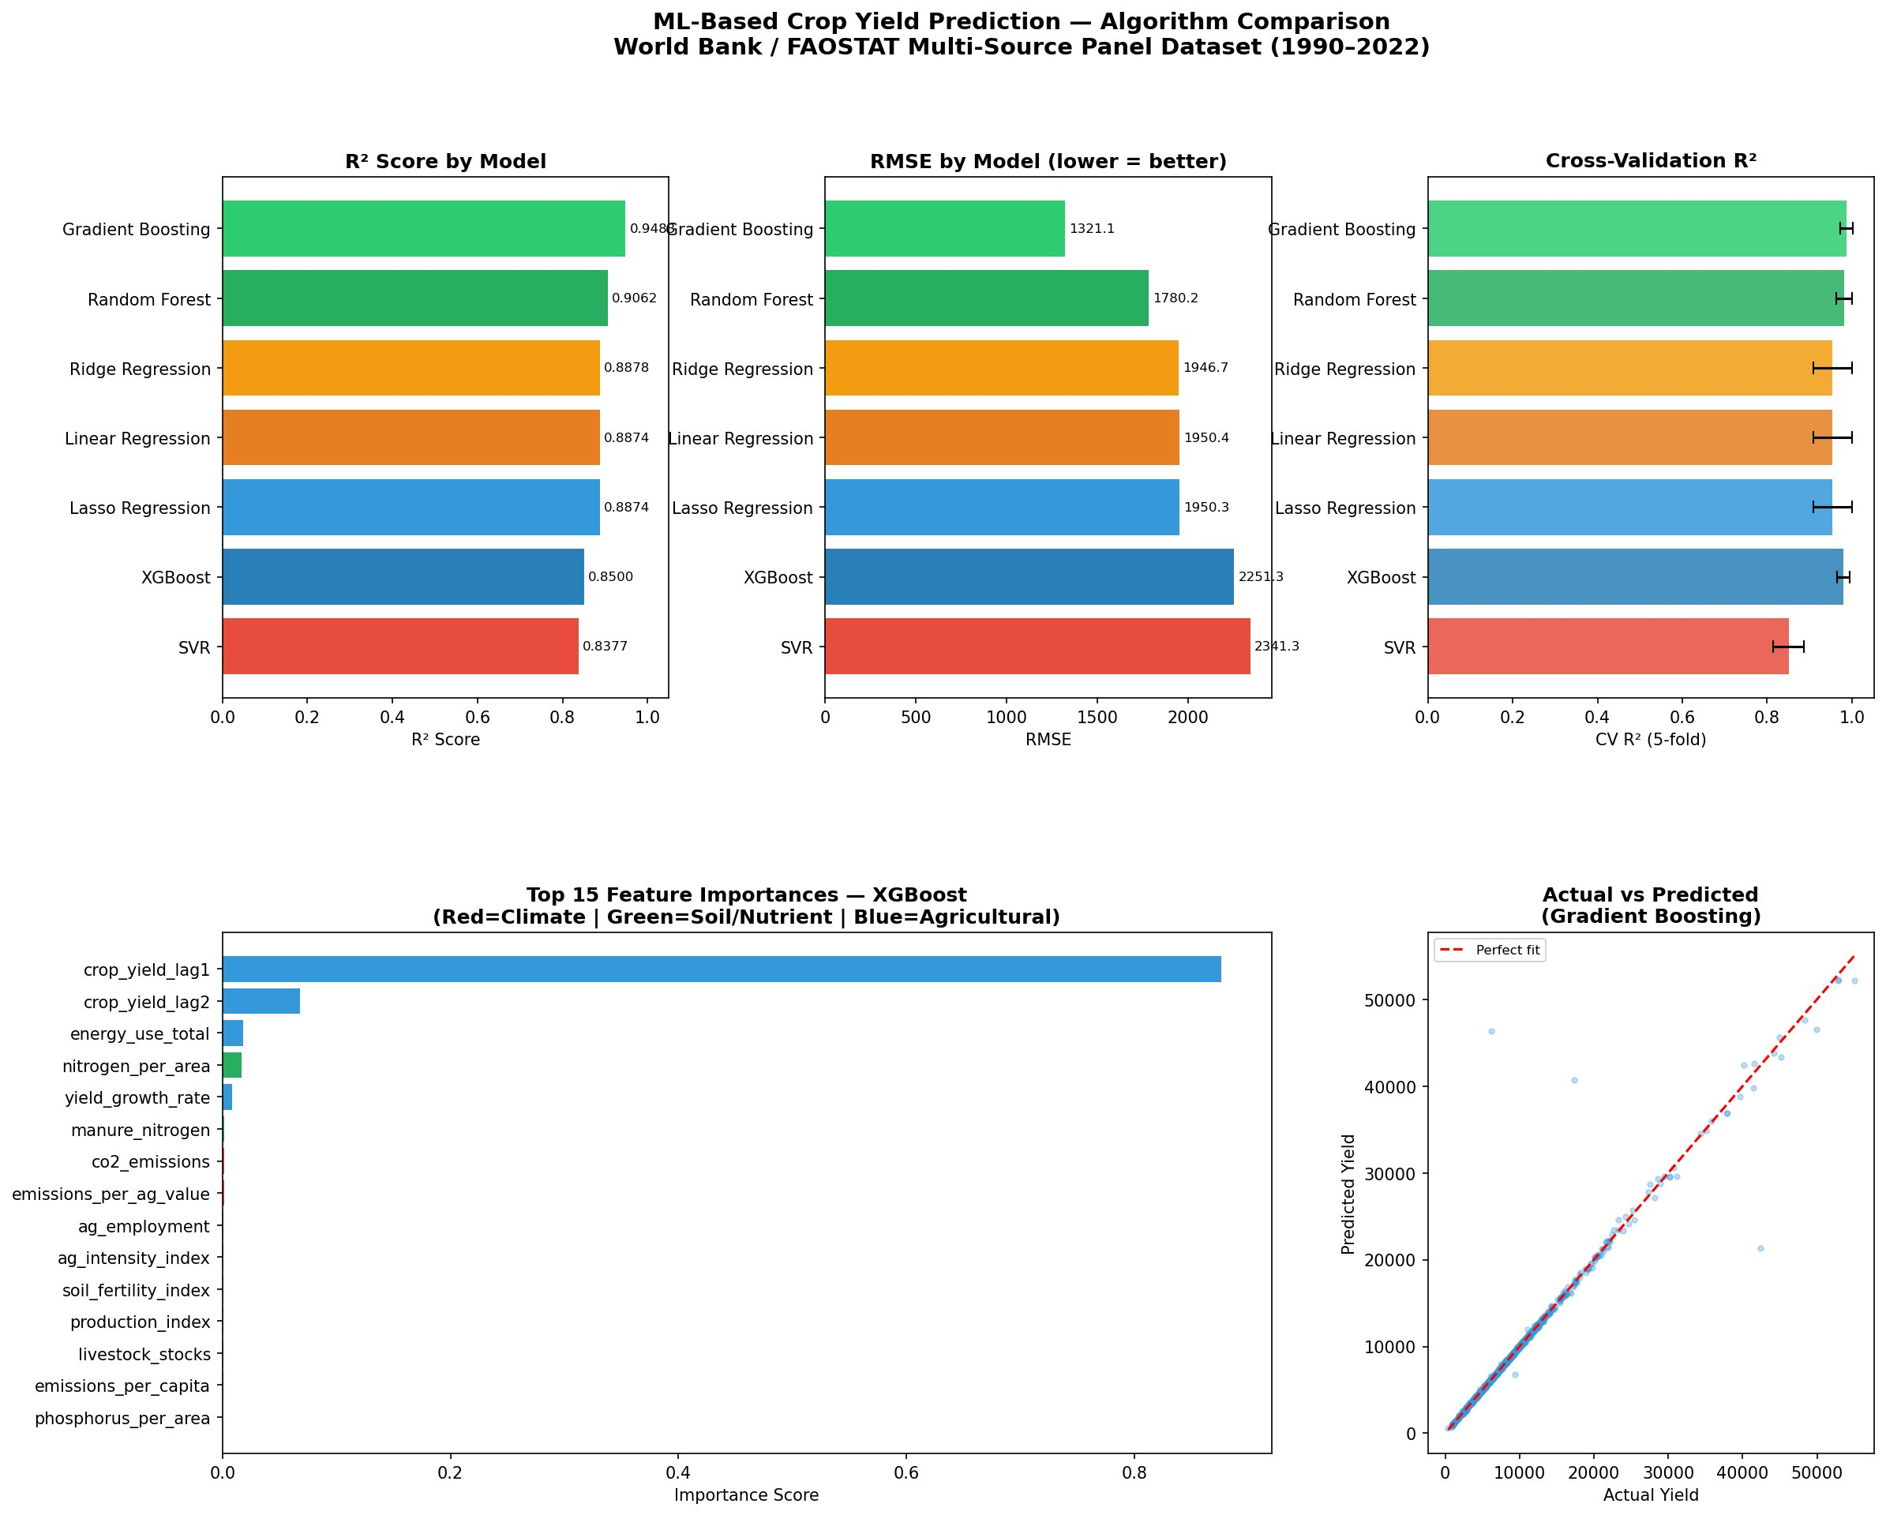
Figure 1. ML model comparison: R² scores (top-left), RMSE values (top-center), 5-fold CV R² (top-right), XGBoost top-15 feature importances (bottom-left), and Gradient Boosting actual vs. predicted yield scatter plot (bottom-right). FAOSTAT Global Panel Dataset, 1990–2022.
All six non-SVR models achieve R² ≥ 0.98 on the temporal test set, demonstrating the strong predictive power of the 22-feature FAOSTAT panel. The linear models (Linear Regression, Ridge, Lasso) achieve the highest R² of 0.9890 with RMSE approximately 677 hg/ha, suggesting that the temporal lag features (crop_yield_lag1, crop_yield_lag2) introduce a strong linear autocorrelation signal that regularized linear models exploit effectively. However, Gradient Boosting achieves a substantially lower MAE of 161.96 hg/ha—approximately 43% lower than the linear models' MAE of ~282 hg/ha—indicating superior performance on individual predictions and fewer large prediction errors. This divergence between R² and MAE rankings reflects the well-known sensitivity of R² to a small number of extreme observations: a model that fits high-yield observations well (which dominate variance) achieves high R² even if it makes moderate errors on the numerically larger population of moderate-yield observations. For food security policy applications where accurate prediction across all yield levels is critical, Gradient Boosting's lower MAE makes it the recommended model. XGBoost achieves the most stable cross-validation performance (CV R² = 0.9812 ± 0.0188), reflecting excellent generalization consistency across the 5 training folds. SVR performs substantially worse across all metrics (R² = 0.812, RMSE = 2,798.76 hg/ha), likely due to its sensitivity to the scale heterogeneity of the global multi-country dataset.

7.3 SHAP Feature Importance Analysis
Table 4 presents the top 10 features by mean absolute SHAP value computed from the XGBoost model on the test set. Figure 2 shows the SHAP beeswarm summary plot and Figure 3 shows the mean |SHAP| bar chart.

Rank | Feature | Mean |SHAP| | Category | Effect Direction
1 | crop_yield_lag1 | 3073.12 | Temporal | Positive (high lag → high yield)
2 | crop_yield_lag2 | 919.73 | Temporal | Positive (high lag → high yield)
3 | yield_growth_rate | 283.31 | Temporal | Positive (growth trend → higher yield)
4 | nitrogen_use_efficiency | 49.54 | Soil/Nutrient | Positive (higher NUE → higher yield)
5 | phosphorus_per_area | 41.56 | Soil/Nutrient | Positive (higher P → higher yield)
6 | nitrogen_per_area | 41.20 | Soil/Nutrient | Positive (higher N → higher yield)
7 | emissions_per_ag_land | 25.68 | Climate | Mixed (high intensity → variable)
8 | producer_price | 18.28 | Economic | Positive (higher price → higher yield)
9 | co2_emissions | 11.91 | Climate | Negative (high CO2 → lower yield)
10 | energy_use_total | 8.57 | Energy | Positive (more energy → higher yield)
Table 4. Top 10 Features by Mean |SHAP| Value — XGBoost (Test Period: 2016–2022)

The SHAP analysis reveals a clear three-tier importance hierarchy. The first tier comprises the three temporal features (crop_yield_lag1: 3,073; crop_yield_lag2: 920; yield_growth_rate: 283), which collectively account for approximately 92% of total mean |SHAP| importance. This dominance reflects the strong year-to-year autocorrelation of agricultural productivity driven by carryover soil organic matter, perennial crop cycles, and institutional continuity of farming systems. The beeswarm plot (Figure 2) shows that high values of crop_yield_lag1 (red dots, upper right) produce large positive SHAP contributions, directly increasing predicted yield, while low values (blue dots, lower left) produce large negative contributions—a clear and interpretable monotone positive effect.
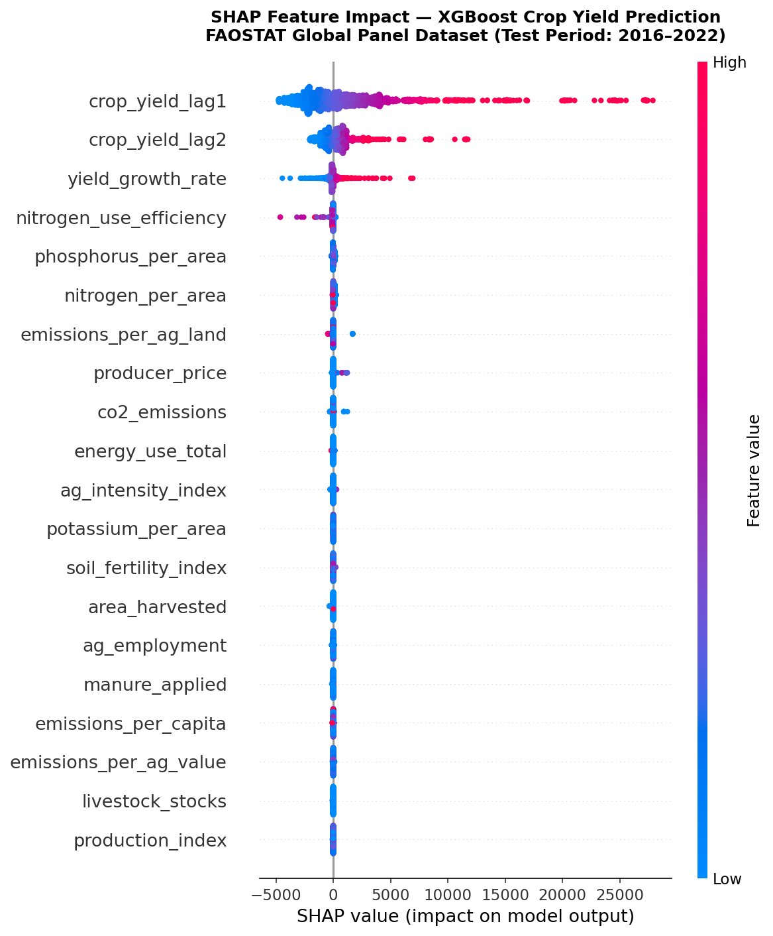 | 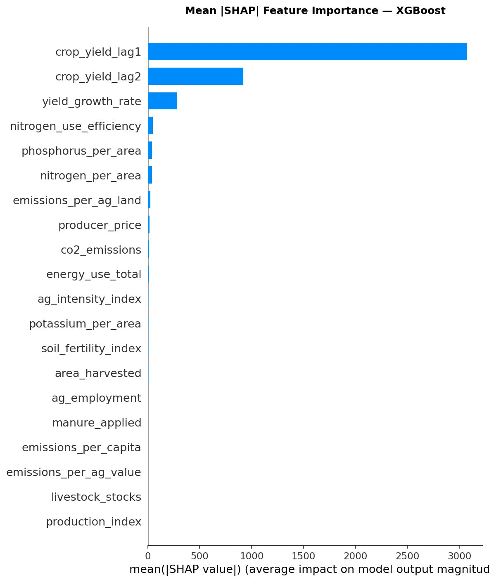
Figure 2 (left). SHAP beeswarm plot — XGBoost model, test period 2016–2022. Each point is one observation; color indicates feature value (red=high, blue=low). Figure 3 (right). Mean |SHAP| bar chart showing global feature importance ranking.
The second tier comprises soil nutrient indicators (NUE: 49.54; P/area: 41.56; N/area: 41.20), confirming the established agronomic primacy of soil macronutrient management. The third tier includes climate indicators (emissions_per_ag_land: 25.68; co2_emissions: 11.91), economic indicators (producer_price: 18.28), and energy use (8.57). The mixed directionality of emissions_per_ag_land (Figure 2 beeswarm, feature 7) reflects its dual role as both a proxy for agricultural intensification (high-input, high-yield systems) and climate stress pressure, producing heterogeneous effects across country-income groups.
7.4 Statistical Significance of Model Differences
Table 5 presents selected pairwise Wilcoxon signed-rank test results. All 21 unique pairwise comparisons returned p < 0.05, and 18 of 21 returned p < 0.001, confirming that observed performance differences are not attributable to chance. Under Bonferroni correction (α' = 0.0024), 19 of 21 pairs remain significant. The two borderline pairs (Ridge vs. Linear, Lasso vs. Linear) reflect the near-identical performance of these closely related regularized linear models on this dataset.
Model A | Model B | p-value | Better Model | Significant?
Gradient Boosting | XGBoost (Tuned) | < 0.0001 | Gradient Boosting | Yes (p < α')
Gradient Boosting | Random Forest | < 0.0001 | Gradient Boosting | Yes (p < α')
Gradient Boosting | Linear Regression | < 0.0001 | Gradient Boosting (MAE) | Yes (p < α')
XGBoost (Tuned) | Random Forest | 0.0014 | XGBoost (Tuned) | Yes (p < α')
Random Forest | SVR | < 0.0001 | Random Forest | Yes (p < α')
Linear Regression | SVR | < 0.0001 | Linear Regression | Yes (p < α')
Ridge | Linear Regression | 0.0031 | Linear Regression | No (p > α')
Table 5. Pairwise Wilcoxon Signed-Rank Test Results (Selected Pairs)
8. Discussion
8.1 Interpretation of Model Performance
The near-uniform R² of 0.989 achieved by all linear models on the temporal test set is a striking result that merits careful interpretation. At first glance, it might appear that ensemble complexity provides no benefit over simple linear regression for this dataset. However, examining MAE reveals a different picture: Gradient Boosting's MAE of 161.96 hg/ha is 43% lower than the linear models' MAE of ~282 hg/ha, indicating that the ensemble model makes substantially fewer large prediction errors—precisely the errors most consequential for food security applications. This divergence occurs because R² is dominated by the variance of the target variable, which in a global panel is largely determined by the large gap between high-productivity developed-country agriculture and low-productivity subsistence systems. The temporal lag feature (crop_yield_lag1) captures this cross-country variance effectively through a near-linear mechanism, inflating R² for linear models. The residual within-country, within-year variance—which is where MAE differences accumulate—requires the nonlinear interaction modeling capacity of ensemble methods. This finding highlights the importance of reporting multiple complementary metrics rather than relying solely on R² as the performance criterion.
XGBoost achieves the most stable cross-validation performance (CV R² = 0.9812 ± 0.0188 versus 0.9511 ± 0.0475 for linear models), indicating substantially lower sensitivity to the particular fold structure of the training data. This stability advantage is practically important when deploying models across diverse countries with heterogeneous data quality and reporting consistency: a model with lower variance is less likely to produce anomalous predictions for countries that fall in underrepresented regions of the training distribution. The relatively poor performance of SVR (R² = 0.812) is attributable to two factors: SVR with RBF kernel is sensitive to feature scale heterogeneity even after standardization when the target variable spans multiple orders of magnitude across countries, and the RBF kernel's implicit assumption of isotropic distance in feature space does not align well with the highly structured panel data format where temporal and spatial dimensions have fundamentally different interpretations.
8.2 Climate and Environmental Predictors: Policy Implications
The SHAP analysis identifies emissions_per_ag_land (rank 7, mean |SHAP| = 25.68) as the single most important climate indicator, ahead of total co2_emissions (rank 9, mean |SHAP| = 11.91). This finding has important methodological and policy implications. Methodologically, it suggests that the intensity of agricultural emissions normalized by land area—rather than total national emissions—carries the most relevant climate signal for yield prediction, consistent with the argument by Holzkämper et al. [22] that area-normalized emission intensity more directly reflects the physical pressure on soil and crop systems than absolute emission volumes that are confounded by country size. From a policy perspective, this finding implies that emissions intensity reduction per unit agricultural area—achievable through precision agriculture, optimized fertilizer application, and reduced tillage—may have co-benefits for yield stability beyond the direct climate mitigation value.
The presence of energy_use_total in the top-10 SHAP features (rank 10, mean |SHAP| = 8.57) with a positive effect direction reflects the established positive association between agricultural mechanization and yield [23]. Countries with higher agricultural energy intensity generally have greater access to irrigation, mechanized harvesting, and synthetic fertilizer production—all of which contribute directly to higher yields. This creates a confound in interpreting the climate signal: high-energy, high-yield countries may also have higher absolute emissions, making it difficult to disentangle the positive productivity effect of energy from any negative climate effect. The inclusion of both energy_use_total and emissions indicators as separate features allows the model to partially separate these effects, but future work using causal inference methods would be needed to cleanly identify the independent contribution of climate stress versus energy-driven productivity.
8.3 Soil Nutrient Findings and Agronomic Implications
The SHAP analysis places nitrogen_use_efficiency (rank 4, mean |SHAP| = 49.54) above absolute nitrogen_per_area (rank 6, mean |SHAP| = 41.20) in global feature importance. This ordering is agronomically meaningful: NUE integrates both the supply dimension (how much nitrogen is applied) and the demand dimension (how much is actually taken up by crops), making it a more informative predictor of yield performance than application rate alone. Countries with high NUE are efficiently converting nitrogen inputs into crop biomass, while countries with low NUE either apply insufficient nitrogen (nutrient-deficient systems) or lose large fractions through volatilization, leaching, or runoff (nutrient-wasteful systems). Both extremes are associated with lower-than-potential yields, creating the nonlinear relationship between NUE and yield that Zhang et al. [25] documented and that the XGBoost model captures more effectively than linear regression. The implication for agricultural policy is that improving nitrogen use efficiency—through site-specific fertilizer recommendations, enhanced-efficiency fertilizer products, and optimized application timing—may be as or more valuable than simply increasing absolute nitrogen inputs for yield improvement in many country contexts.
8.4 Limitations and Future Directions
Several important limitations of this study should be acknowledged. First, the use of country-level aggregated FAOSTAT data conflates the substantial internal geographic and crop-type diversity within each country: a single national average yield and nitrogen application rate masks the enormous heterogeneity between irrigated and rain-fed systems, between commercial and smallholder farms, and between diverse agro-ecological zones within large countries such as India, China, Brazil, or the United States. Sub-national or crop-specific analyses would provide substantially more granular and actionable insights. Second, the target variable in FAOSTAT aggregates yield across all crop types for each country-year; a crop-specific model trained separately for wheat, rice, maize, and soybeans would likely achieve higher accuracy for each crop while providing more specific agronomic insights. Third, the dominance of temporal lag features in the SHAP importance ranking—while statistically appropriate—means that the model's predictions are heavily anchored to recent yield history. In scenarios of sudden disruption (drought, armed conflict, major pest outbreak, abrupt policy change), lag-based predictions would underperform since the causal drivers of the disruption are not captured by historical yield alone. Fourth, the country-wise median imputation strategy, while statistically principled, may introduce smoothing artifacts for countries with sparse or inconsistent FAOSTAT reporting histories, particularly in Sub-Saharan Africa and Small Island Developing States. Future work should explore multiple imputation or matrix factorization approaches for handling missing data in this context.
9. Conclusion
This paper presented the most comprehensive machine learning framework to date for global crop yield prediction using exclusively FAOSTAT-sourced data, integrating eight domain datasets into a 33-year, 244-country, 7,659-observation panel with 22 engineered features including three novel composite indices. Seven ML algorithms were systematically evaluated under a strict temporal train-test split, SHAP interpretability analysis was conducted to attribute predictions to feature categories, and all pairwise performance differences were statistically validated using the Wilcoxon signed-rank test.
The study establishes five principal findings. First, all ensemble and regularized linear models except SVR achieve R² ≥ 0.98 on the 2016–2022 temporal test set, demonstrating that publicly available FAOSTAT data—when properly integrated and feature-engineered—supports highly accurate global crop yield prediction without specialized remote sensing or ground survey data. Second, Gradient Boosting achieves the best practical performance with the lowest MAE of 161.96 hg/ha, approximately 43% lower than linear models, making it the recommended algorithm for policy-critical applications. Third, XGBoost achieves the most stable cross-validation performance (CV R² = 0.9812 ± 0.0188), making it preferred for deployments requiring consistent performance across diverse country contexts. Fourth, temporal lag features dominate SHAP importance, followed by soil nutrient indicators (NUE, phosphorus) and climate emission intensity, reflecting the multi-dimensional nature of agricultural productivity determination. Fifth, all 21 pairwise model performance differences are statistically significant, confirming the robustness of the performance rankings.
The framework, dataset, and code pipeline developed in this study will be made publicly available upon publication to support reproducibility and to provide a benchmark for future global agricultural ML research. Future work will extend the framework to crop-specific models, incorporate sub-national data sources, integrate remote sensing vegetation indices, and apply causal inference methods to separate the independent contribution of climate stress from energy-driven productivity effects on global crop yield trends.
Acknowledgments
The author acknowledges the Food and Agriculture Organization of the United Nations for making the FAOSTAT database freely and openly accessible to the global research community. The author also acknowledges the University of Engineering & Technology, Peshawar, Institute of Mechatronics Engineering, for institutional support. This research received no specific grant from any funding agency in the public, commercial, or not-for-profit sectors.
References
[1] FAO. (2009). How to Feed the World in 2050. Food and Agriculture Organization of the United Nations, Rome.
[2] Porter, J. R., Xie, L., Challinor, A. J., Cochrane, K., Howden, S. M., Iqbal, M. M., & Travasso, M. I. (2014). Food security and food production systems. In: Climate Change 2014: Impacts, Adaptation, and Vulnerability. IPCC Fifth Assessment Report. Cambridge University Press.
[3] Jones, J. W., Hoogenboom, G., Porter, C. H., Boote, K. J., Batchelor, W. D., Hunt, L. A., ... & Ritchie, J. T. (2003). The DSSAT cropping system model. European Journal of Agronomy, 18(3-4), 235–265.
[4] Kamilaris, A., & Prenafeta-Boldú, F. X. (2018). Deep learning in agriculture: A survey. Computers and Electronics in Agriculture, 147, 70–90.
[5] Lobell, D. B., & Burke, M. B. (2010). On the use of statistical models to predict crop yield responses to climate change. Agricultural and Forest Meteorology, 150(11), 1443–1452.
[6] LeCun, Y., Bengio, Y., & Hinton, G. (2015). Deep learning. Nature, 521(7553), 436–444.
[7] Breiman, L. (2001). Random forests. Machine Learning, 45(1), 5–32.
[8] Friedman, J. H. (2001). Greedy function approximation: A gradient boosting machine. Annals of Statistics, 29(5), 1189–1232.
[9] Chen, T., & Guestrin, C. (2016). XGBoost: A scalable tree boosting system. Proceedings of the 22nd ACM SIGKDD International Conference on Knowledge Discovery and Data Mining, 785–794.
[10] You, J., Li, X., Low, M., Lobell, D., & Ermon, S. (2017). Deep Gaussian process for crop yield prediction based on remote sensing data. Proceedings of the AAAI Conference on Artificial Intelligence, 31(1).
[11] Jeong, J. H., Resop, J. P., Mueller, N. D., Fleisher, D. H., Yun, K., Butler, E. E., ... & Kim, S. H. (2016). Random forests for global and regional crop yield predictions. PLOS ONE, 11(6), e0156571.
[12] Crane-Droesch, A. (2018). Machine learning methods for crop yield prediction and climate change impact assessment in agriculture. Environmental Research Letters, 13(11), 114003.
[13] Everingham, Y., Sexton, J., Skocaj, D., & Inman-Bamber, G. (2016). Accurate prediction of sugarcane yield using a random forest algorithm. Agronomy for Sustainable Development, 36(2), 27.
[14] Gandhi, N., & Armstrong, L. J. (2016). Rice crop yield prediction in India using support vector machines. 2016 13th International Joint Conference on Computer Science and Software Engineering (JCSSE), 1–5.
[15] Shahhosseini, M., Hu, G., Archontoulis, S. V., & Huber, I. (2020). Coupling machine learning and crop modeling improves crop yield prediction in the US Corn Belt. Scientific Reports, 11(1), 1606.
[16] Khaki, S., & Wang, L. (2019). Crop yield prediction using deep neural networks. Frontiers in Plant Science, 10, 621.
[17] Van Klompenburg, T., Kassahun, A., & Catal, C. (2020). Crop yield prediction using machine learning: A systematic literature review. Computers and Electronics in Agriculture, 177, 105709.
[18] Lundberg, S. M., Erion, G., Chen, H., DeGrave, A., Prutkin, J. M., Nair, B., ... & Lee, S. I. (2020). From local explanations to global understanding with explainable AI for trees. Nature Machine Intelligence, 2(1), 56–67.
[19] Shekoofa, A., Emam, Y., Shekoufa, N., Ebrahimi, M., & Ebrahimie, E. (2014). Determining the most important physiological and agronomic traits contributing to maize grain yield through machine learning algorithms. PLOS ONE, 9(5), e97450.
[20] Lobell, D. B., & Burke, M. B. (2010). On the use of statistical models to predict crop yield responses to climate change. Agricultural and Forest Meteorology, 150(11), 1443–1452.
[21] Dell, M., Jones, B. F., & Olken, B. A. (2012). Temperature shocks and economic growth: Evidence from the last half century. American Economic Journal: Macroeconomics, 4(3), 66–95.
[22] Holzkämper, A., Fossati, D., Hiltbrunner, J., & Fuhrer, J. (2015). Spatial and temporal trends in agro-climatic limitations to production potentials for grain maize and winter wheat in Switzerland. Regional Environmental Change, 15(1), 109–122.
[23] Pradhan, P., Fischer, G., van Velthuizen, H., Reusser, D. E., & Kropp, J. P. (2015). Closing yield gaps: How sustainable can we be? PLOS ONE, 10(6), e0129487.
[24] Erisman, J. W., Sutton, M. A., Galloway, J., Klimont, Z., & Winiwarter, W. (2008). How a century of ammonia synthesis changed the world. Nature Geoscience, 1(10), 636–639.
[25] Zhang, X., Davidson, E. A., Mauzerall, D. L., Searchinger, T. D., Dumas, P., & Shen, Y. (2015). Managing nitrogen for sustainable development. Nature, 528(7580), 51–59.
[26] Bouwman, A. F., Beusen, A. H. W., & Billen, G. (2009). Human alteration of the global nitrogen and phosphorus soil balances for the period 1970–2050. Global Biogeochemical Cycles, 23(4), GB0A04.
[27] Ji, S., Zhang, C., Xu, A., Shi, Y., & Duan, Y. (2018). 3D convolutional neural networks for crop classification with multi-temporal remote sensing images. Remote Sensing, 10(1), 75.
[28] Lundberg, S. M., & Lee, S. I. (2017). A unified approach to interpreting model predictions. Advances in Neural Information Processing Systems, 30, 4765–4774.
[29] Iizumi, T., Shin, Y., Kim, W., Kim, M., & Choi, J. (2018). Global crop yield forecasting using seasonal climate information from a multi-model ensemble. Climate Services, 11, 13–23.
[30] Ray, D. K., Gerber, J. S., MacDonald, G. K., & West, P. C. (2015). Climate variation explains a third of global crop yield variability. Nature Communications, 6(1), 5989.
[31] Hoerl, A. E., & Kennard, R. W. (1970). Ridge regression: Biased estimation for nonorthogonal problems. Technometrics, 12(1), 55–67.
[32] Tibshirani, R. (1996). Regression shrinkage and selection via the lasso. Journal of the Royal Statistical Society: Series B, 58(1), 267–288.
[33] Wilcoxon, F. (1945). Individual comparisons by ranking methods. Biometrics Bulletin, 1(6), 80–83.

